|  |  |
| --- | --- |
| **Angular** | **2021** |

# 1. Validate User Input Using Angular Model Driven

Refer the web page given below and write JavaScript code to validate the user input as listed below

1. Text boxes should not remain blank
2. Postal code should have exactly six digits, such as 123456
3. Mail id should be validated

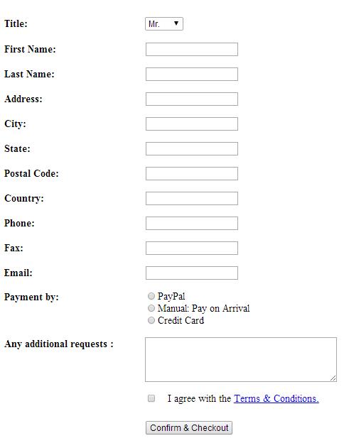

Figure 1: User Details Confirmation and Checkout page